9:00 – 10:10 – Jumppads, Spikes and Moving Platforms

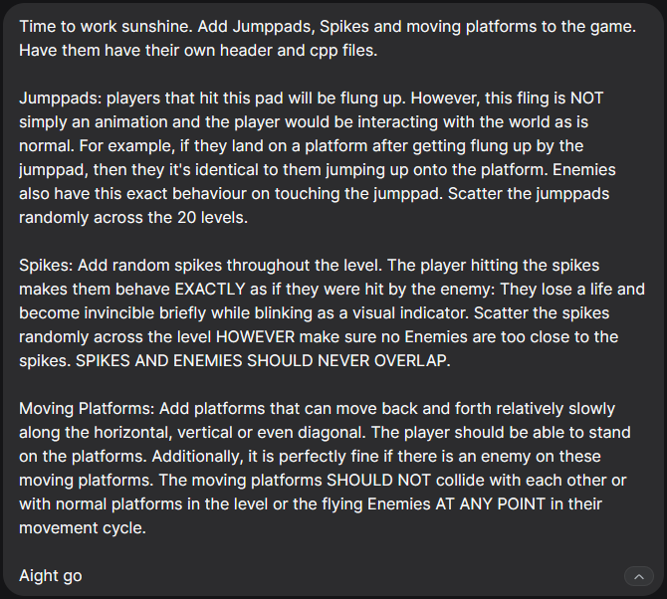

After yesterday’s merge conflict, I hadn’t updated the new files/changes into the AI Agent. So here’s me doing that:
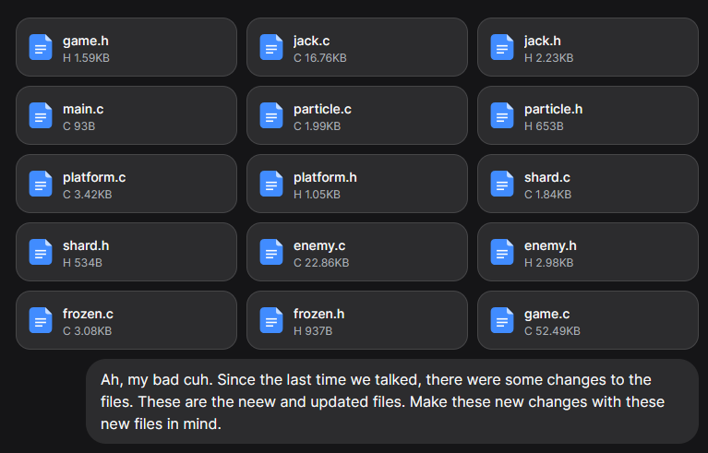

It generated a mistake in the game.c file:
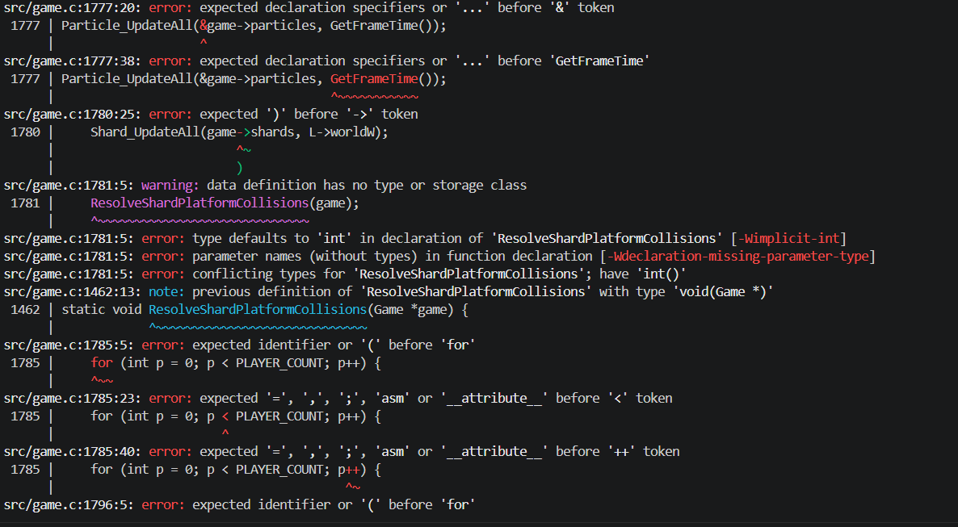

After looking at the error, I realized it re-wrote parts of the update function as a separate function ????
No idea why this happened but the fix was very simple – just remove this rogue write-up
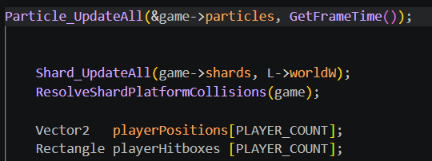
Since this was a small fix, I did it manually.

Improving level design:
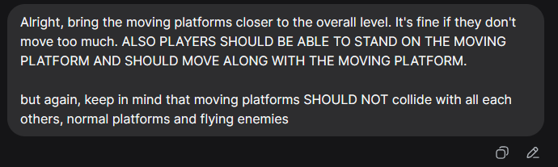

10:10 - ??? – Adding Level Editor/Creator

